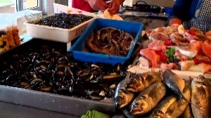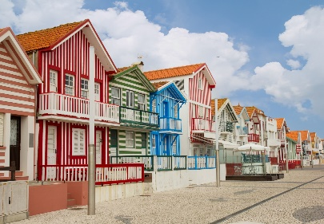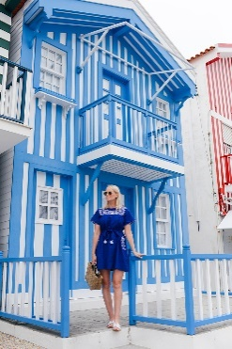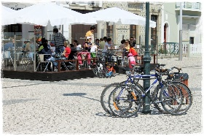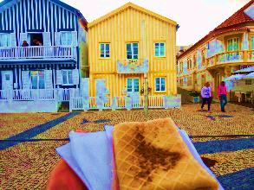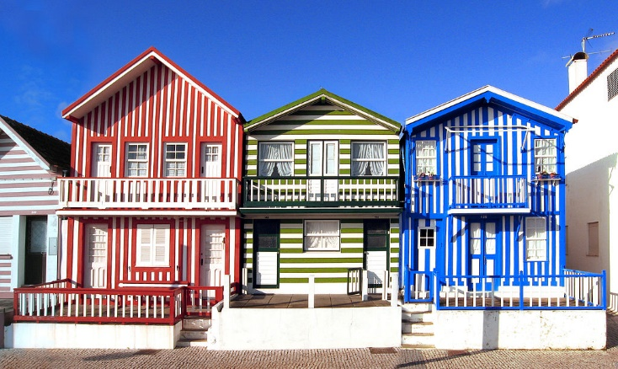

### WE TAKE YOU TO COSTA NOVA

**Only 20 eur** / Return Ticket

**Couple 35 eur – 4 pax 50 eur**

**BOOK NOW aveirocentral.com**

**Contatos**:Paulo: +351 965 380 114 **We speak**



Costa- Nova

### Estimated Time: 2 hours

**Go with a PROFISSIONAL & LOCAL GUIDE**

52353/AL RNAAT: 598/2019



Visit Costa NOVA

Private Tour – to Costa Nova